Unit 394
www,boisebridge.club

BOISE FALL SECTIONAL
Friday, Sept 8, 2023 Stratified Open Pairs – 10:00 AM and 3:00 PM 0-199er games – 10: AM and 3:00 PM

Saturday, Sept 9, 2023 Stratified Open Pairs – 10 AM and 3:00 PM 0-199er games – 10 AM and 3:00 PM

Sunday, Sept 10, 2023 Stratified Swiss Teams – 10:00 AM

Master Point Ranges: A=unlimited, B=750-1500, C=0-750 Stratified by Team or Pair Average
Location Holiday Inn Boise Express 3050 S. S St. Boise, ID 83705 208-914-2065
Special Residence Room Rate: $119.00 Booking deadline August 8, 2023

Tournament Director Jeff Jacob
Tournament Chairperson Kathy Dowen dowenkathy@gmail.com 208-724-7158
Partnership Chairperson Carol Holmes carolholmes67@gmail.com 208-866-7766
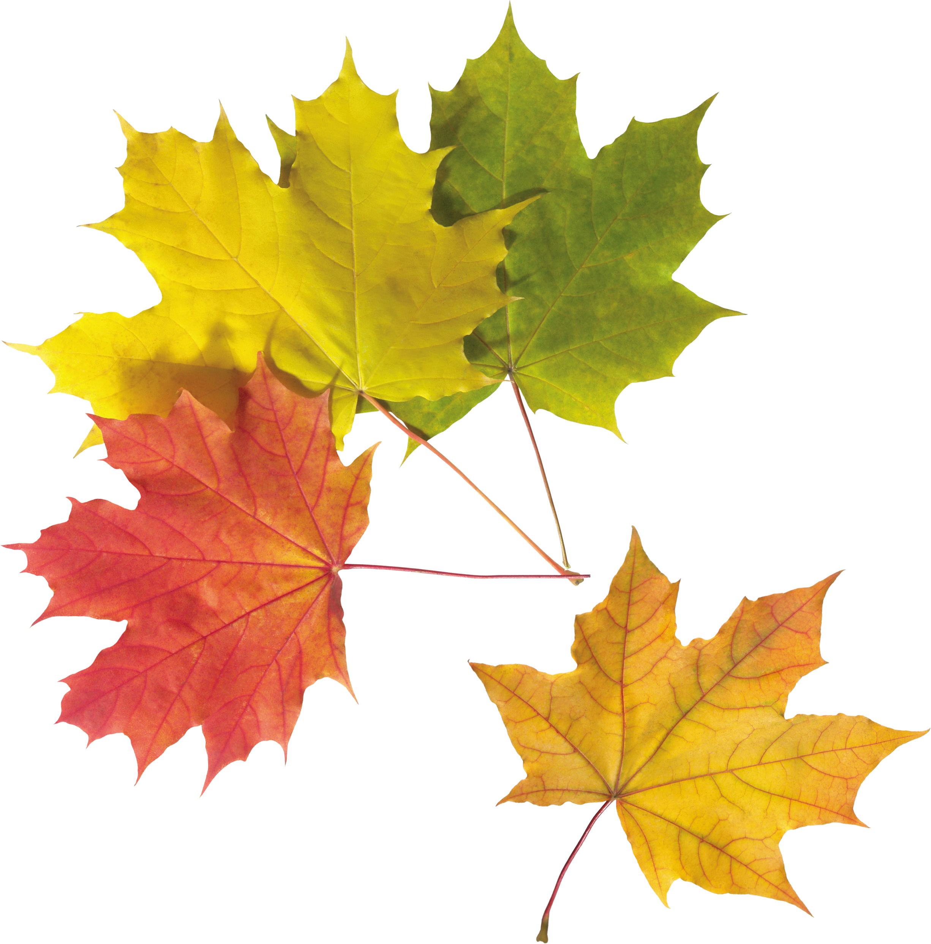
Entry Fees Friday and Saturday $12.00 per person per session $15.00 for lapsed ACBL members per session
Sunday: $96 per Team NO LUNCH SERVED

